In the billing Header data

When click on the document no. it need to show the item data in new page.

When we click on the payerno it should show the XD03

In the item data page when we click on the material no it should show the mm03.

Please find the attached screen shots for the above task assessment

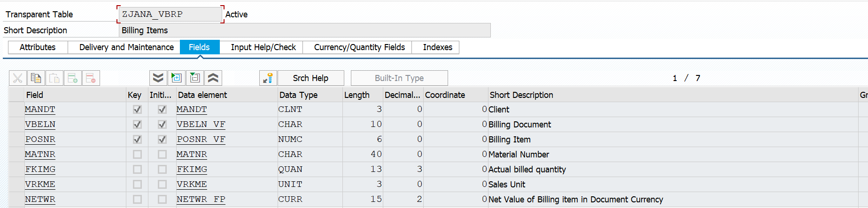

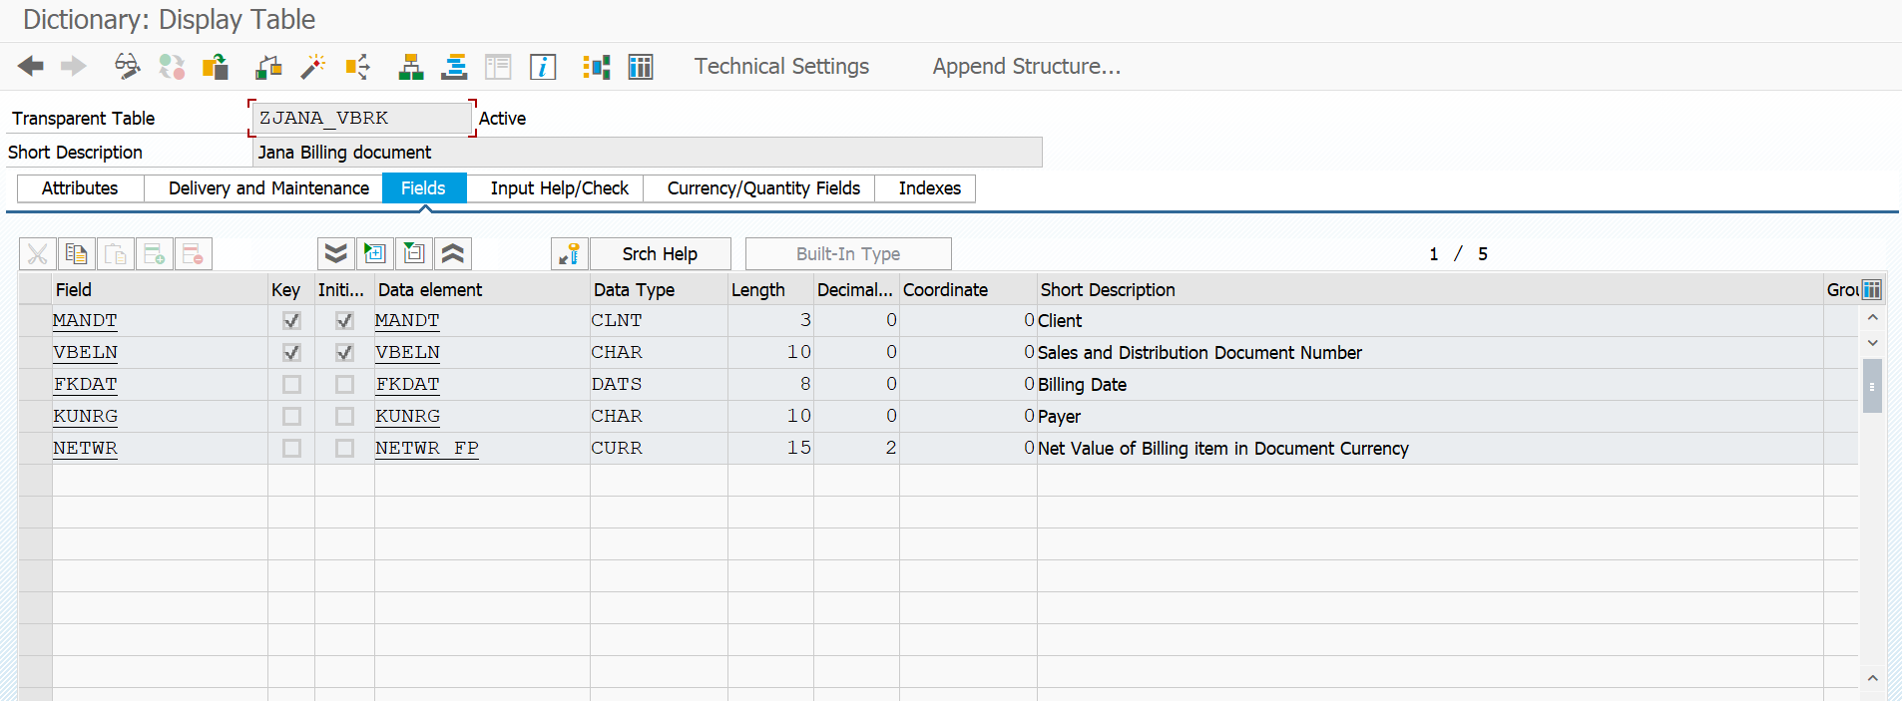

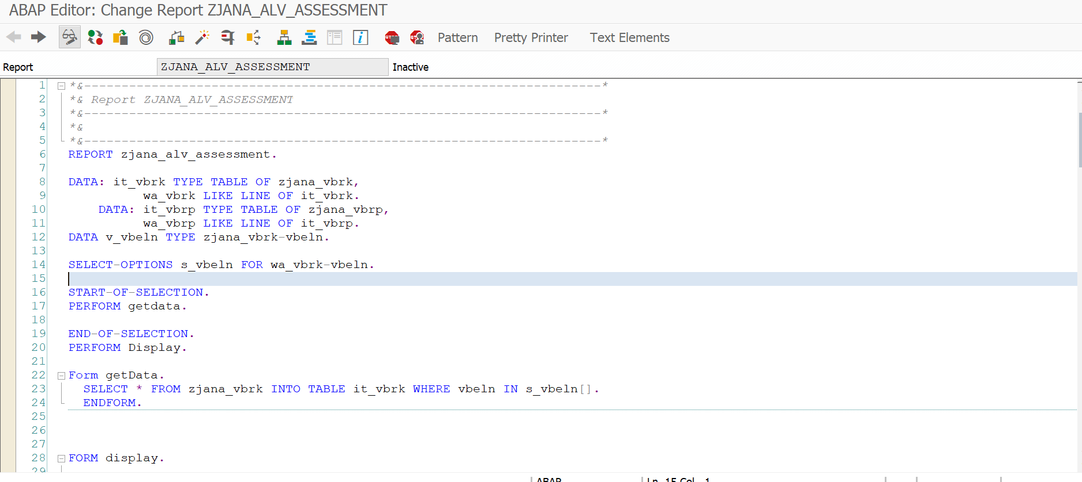

*&---------------------------------------------------------------------*  
*& Report ZJANA_ALV_ASSESSMENT  
*&---------------------------------------------------------------------*  
*&  
*&---------------------------------------------------------------------*  
REPORT zjana_alv_assessment.  
  
DATA: it_vbrk TYPE TABLE OF zjana_vbrk,  
          wa_vbrk LIKE LINE OF it_vbrk.  
    DATA: it_vbrp TYPE TABLE OF zjana_vbrp,  
          wa_vbrp LIKE LINE OF it_vbrp.  
DATA v_vbeln TYPE zjana_vbrk-vbeln.  
  
SELECT-OPTIONS s_vbeln FOR wa_vbrk-vbeln.  
  
START-OF-SELECTION.  
PERFORM getdata.  
  
END-OF-SELECTION.  
PERFORM Display.  
  
Form getData.  
  SELECT * FROM zjana_vbrk INTO TABLE it_vbrk WHERE vbeln IN s_vbeln[].  
  ENDFORM.  
  
  
  
FORM display.  
  
CALL FUNCTION 'REUSE_ALV_GRID_DISPLAY'  
  EXPORTING  
*   I_INTERFACE_CHECK       = ' '  
*   I_BYPASSING_BUFFER      = ' '  
*   I_BUFFER_ACTIVE         = ' '  
    i_callback_program      = 'ZJANA_ALV_ASSESSMENT'  
*   I_CALLBACK_PF_STATUS_SET          = ' '  
    i_callback_user_command = 'USER_COMMAND'  
*   I_CALLBACK_TOP_OF_PAGE  = ' '  
*   I_CALLBACK_HTML_TOP_OF_PAGE       = ' '  
*   I_CALLBACK_HTML_END_OF_LIST       = ' '  
    I_STRUCTURE_NAME        = 'ZJANA_vbrk'  
*   I_BACKGROUND_ID         = ' '  
*   I_GRID_TITLE            =  
*   I_GRID_SETTINGS         =  
*   IS_LAYOUT               =  
*   IT_FIELDCAT             =  
*   IT_EXCLUDING            =  
*   IT_SPECIAL_GROUPS       =  
*   IT_SORT                 =  
*   IT_FILTER               =  
*   IS_SEL_HIDE             =  
*   I_DEFAULT               = 'X'  
*   I_SAVE                  = ' '  
*   IS_VARIANT              =  
*   IT_EVENTS               =  
*   IT_EVENT_EXIT           =  
*   IS_PRINT                =  
*   IS_REPREP_ID            =  
*   I_SCREEN_START_COLUMN   = 0  
*   I_SCREEN_START_LINE     = 0  
*   I_SCREEN_END_COLUMN     = 0  
*   I_SCREEN_END_LINE       = 0  
*   I_HTML_HEIGHT_TOP       = 0  
*   I_HTML_HEIGHT_END       = 0  
*   IT_ALV_GRAPHICS         =  
*   IT_HYPERLINK            =  
*   IT_ADD_FIELDCAT         =  
*   IT_EXCEPT_QINFO         =  
*   IR_SALV_FULLSCREEN_ADAPTER        =  
*   O_PREVIOUS_SRAL_HANDLER =  
*     IMPORTING  
*   E_EXIT_CAUSED_BY_CALLER =  
*   ES_EXIT_CAUSED_BY_USER  =  
  TABLES  
    t_outtab                = it_vbrk  
  EXCEPTIONS  
    program_error           = 1  
    OTHERS                  = 2.  
IF sy-subrc <> 0.  
* Implement suitable error handling here  
ENDIF.  
ENDFORM.  
  
FORM user_command USING r_ucomm LIKE sy-ucomm  
                                  rs_selfield TYPE slis_selfield.  
   IF r_ucomm EQ '&IC1' AND rs_selfield-fieldname EQ 'VBELN'.  
  
  DATA v_vbeln TYPE vbeln.  
    v_vbeln = rs_selfield-value.  
    CALL FUNCTION 'CONVERSION_EXIT_ALPHA_INPUT'  
      EXPORTING  
        input  = v_vbeln  
      IMPORTING  
        output = v_vbeln.  
     Select * from zjana_vbrp INTO TABLE it_vbrp where vbeln = v_vbeln.  
       CALL FUNCTION 'REUSE_ALV_GRID_DISPLAY'  
        EXPORTING  
*          I_INTERFACE_CHECK                 = ' '  
*          I_BYPASSING_BUFFER                = ' '  
*          I_BUFFER_ACTIVE                   = ' '  
         I_CALLBACK_PROGRAM                = 'ZJANA_ALV_ASSESSMENT'  
*          I_CALLBACK_PF_STATUS_SET          = ' '  
          I_CALLBACK_USER_COMMAND           = 'USER_COMMAND'  
*          I_CALLBACK_TOP_OF_PAGE            = ' '  
*          I_CALLBACK_HTML_TOP_OF_PAGE       = ' '  
*          I_CALLBACK_HTML_END_OF_LIST       = ' '  
        I_STRUCTURE_NAME                  = 'ZJANA_vbrp'  
*          I_BACKGROUND_ID                   = ' '  
*          I_GRID_TITLE                      =  
*          I_GRID_SETTINGS                   =  
*          IS_LAYOUT                         =  
*          IT_FIELDCAT                       =  
*          IT_EXCLUDING                      =  
*          IT_SPECIAL_GROUPS                 =  
*          IT_SORT                           =  
*          IT_FILTER                         =  
*          IS_SEL_HIDE                       =  
*          I_DEFAULT                         = 'X'  
*          I_SAVE                            = ' '  
*          IS_VARIANT                        =  
*          IT_EVENTS                         =  
*          IT_EVENT_EXIT                     =  
*          IS_PRINT                          =  
*          IS_REPREP_ID                      =  
*          I_SCREEN_START_COLUMN             = 0  
*          I_SCREEN_START_LINE               = 0  
*          I_SCREEN_END_COLUMN               = 0  
*          I_SCREEN_END_LINE                 = 0  
*          I_HTML_HEIGHT_TOP                 = 0  
*          I_HTML_HEIGHT_END                 = 0  
*          IT_ALV_GRAPHICS                   =  
*          IT_HYPERLINK                      =  
*          IT_ADD_FIELDCAT                   =  
*          IT_EXCEPT_QINFO                   =  
*          IR_SALV_FULLSCREEN_ADAPTER        =  
*          O_PREVIOUS_SRAL_HANDLER           =  
*        IMPORTING  
*          E_EXIT_CAUSED_BY_CALLER           =  
*          ES_EXIT_CAUSED_BY_USER            =  
         TABLES  
           t_outtab                          = it_vbrp  
        EXCEPTIONS  
          PROGRAM_ERROR                     = 1  
          OTHERS                            = 2  
                 .  
       IF sy-subrc <> 0.  
* Implement suitable error handling here  
       ENDIF.  
  
ELSEIF r_ucomm EQ '&IC1' AND rs_selfield-fieldname EQ 'KUNRG'.  
  SET PARAMETER ID 'KUN' FIELD rs_selfield-value.  
    CALL TRANSACTION 'XD03'.  
  
  ELSEIF r_ucomm EQ '&IC1' AND rs_selfield-fieldname EQ 'MATNR'.  
    SET PARAMETER ID 'MAT' FIELD rs_selfield-value.  
    CALL TRANSACTION 'MM03'.  
  ENDIF.  
  
ENDFORM.

